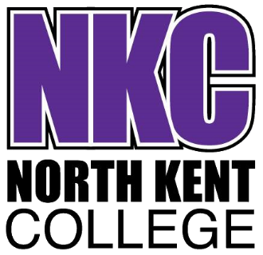
Pre carpentry interview Questionnaire

You have applied for the Diploma L1 in Carpentry & Joinery at Course at North Kent College.
Please complete the questions below and then return via email to; Admissions@northkent.ac.uk

Your Name;
Your Address;
Your Phone number;
Your email address;

Parents Name;
Parents Phone number;
Parents email address;

- What excites you about studying the carpentry trade?

- What is meant by the term Bench Joinery?

- What is meant by the term Site Carpentry?

- Which part of the industry interests you the most and why?

- What do you know about the subject you are applying to study?

- Why do you want to attend this North Kent College in particular?

- What are your short-term and long-term goals?

- What do you like to do in your spare time?

- Have you ever done any volunteering?

- What makes you more suitable for the course than another applicant with the same grades?

- Please attach a copy of your latest school report.

